**Magnolia Drilling Project**

**Extern Team** will consist of three MS students lead by Dr. George Wong. Additional faculty support will be provided by Dr. Evren Ozbayoglu and Dr. Silvio Baldino from University of Tulsa.



**Challenge:** MGY is attempting to establish a maximum achievable lateral length under various kickout distances in the Giddings field. The drilling environment is extremely dynamic and there are numerous variables that impact our torque and drag profile, making it very hard to predict or say with confidence to what extent extended laterals can be drilled. Variables include TVD which directly drives top hole wellbore geometry and inclination, location of faulting/fracturing (and associated pressures – depleted/pressured) along curve and lateral hole sections, and type of drilling fluid (on returns with OBM or on mud cap with water).

In addition to technical considerations, the extern team will tie in the commercial aspects to provide scale to the risk matrix in terms of capital impact. Risk tolerance of MGY will be surveyed and agreed to in order to validate risk matrix assumptions (care will be taken to determine **MGY risk tolerance** over that of individuals).

**Approach:** The Extern Team will complete Torque and Drag history matching of up to 25 wells to refine model assumptions in order to have a predictive tool reliable to determine expected parameters to be encountered under various development scenarios. The team will determine the ranges of uncertainty expected with the tool and various torque and drag model parameters to calculate limits on drilling effectiveness to deliver planned well scope. As an aside, the team will determine conditions where discretionary items should be eliminated such as additional logs, core, etc. The team will also research costs related to trouble time or mitigating activities like back reaming in order to provide severity scale to risk (for example 10% more well costs expected to loss of hole/well costs).

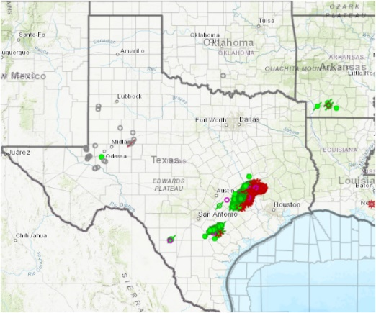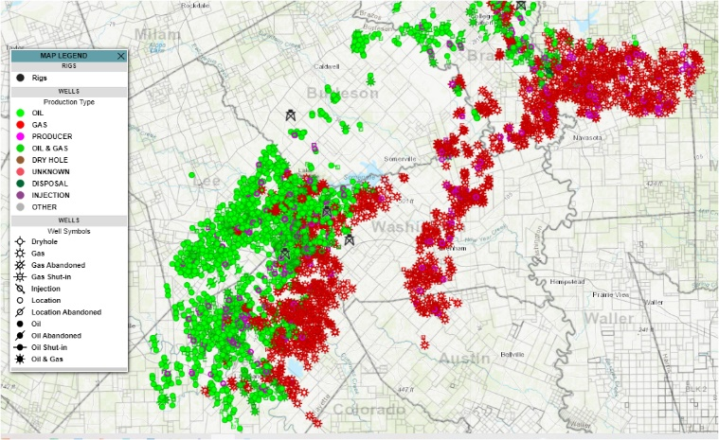

**Deliverables**:

1. Refined risk matrix that details kickout and lateral length – similar to the below.

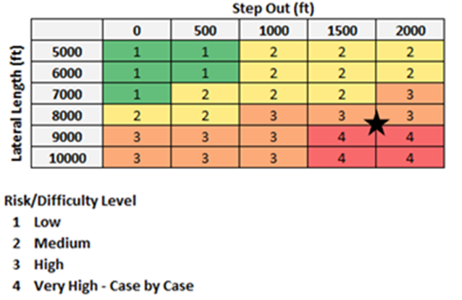

1. Summary report and description of Torque and Drag model to a level that MGY may duplicate the work and keep the tool evergreen.

**Data Sources**: Pason EDR Data, Directional Survey Data, Daily Drilling Reports, Mud Reports, Mud Logs (Students will be given log on ID’s for Pason Data for the selected wells)

**Data Provided**

* + Detailed trajectory of the well to be drilled, including KOP, build rate(s), turn rate(s) and associated MDs
  + Wellbore sizes (as a function of MD)
  + Drillstring component (at least “general” items, such as drillpipes, HW-DPs, BHA) lengths, sizes (OD-ID), unit weights, and if possible, yield stress (in case von Mises failure analysis is requested)
  + Fluids present in the annulus (since Mud Cap drilling application is considered, there should be 2 of them), and if available, what “wellbore friction” is considered
  + Pason data during drilling for up to 25 wells (i.e., bit is NOT off-bottom) to support the max WOB and torque on bit expected during various well conditions
  + Sufficient subsurface data to enable the students to understand geohazards and the impact of wellbore direction on drilling difficulties.

**About Magnolia**

